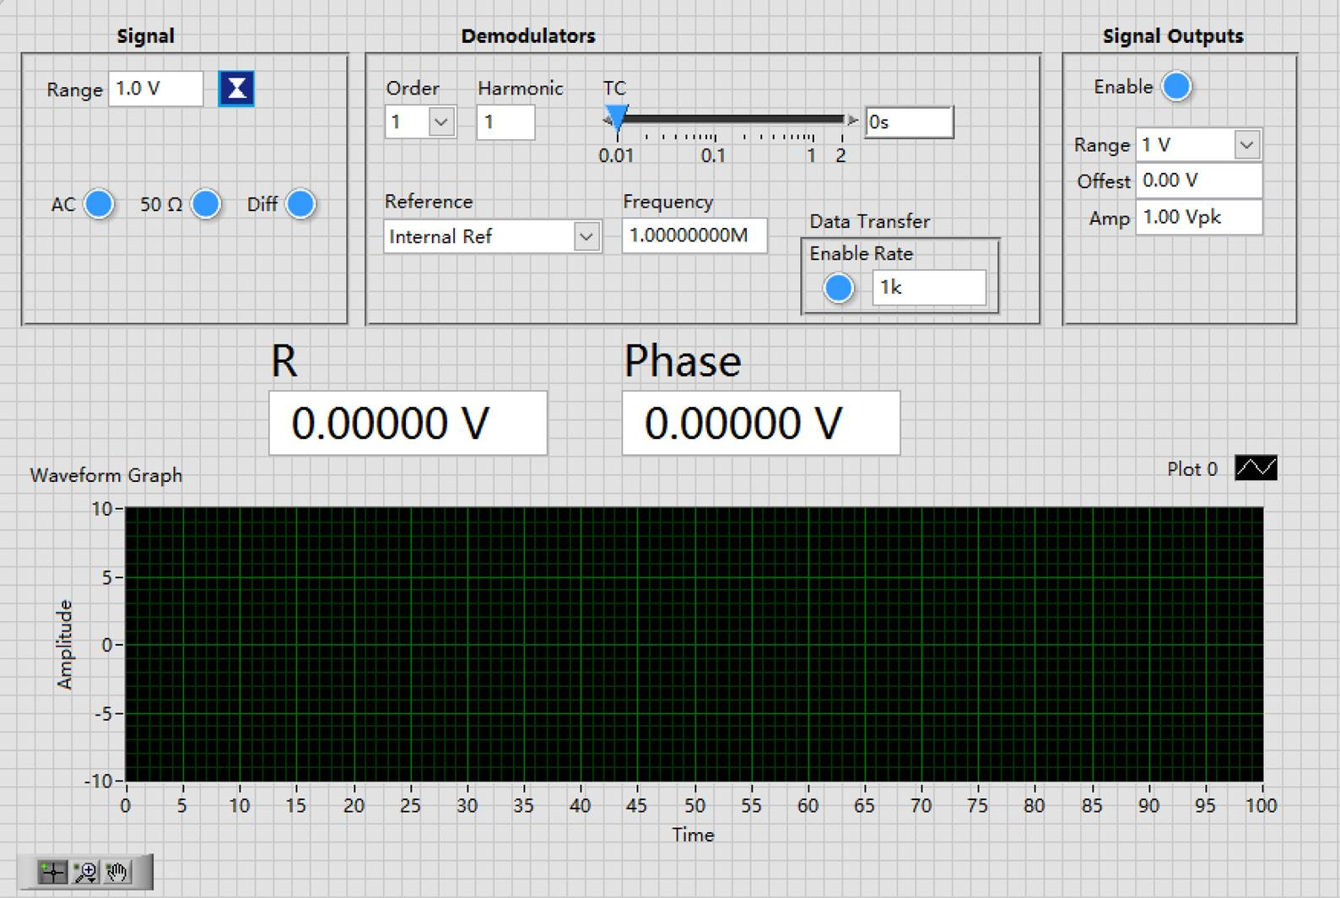

I am correcting in English but it applies to the Chinese version

1. Text too small everywhere
2. Change label Signal to Input Channel
3. Change Signal Output to Reference Output
4. MFLI has a float option in Input Channel as well
5. HF2LI does not have Offset field
6. Is it possible to automatically remove or add settings based on the type of instrument detected?
7. Add an LED beside Frequency: LED on (blue) when Internal Ref used or when Ext Ref is locked ; red when Ext Ref not locked
8. Have an option to enable showing (R, phase) or (X, Y)
9. Automatically change data transfer rate when TC is changed. This can be done by internally converting TC to BW 3dB and then set data transfer rate to say 6-10 time bigger. But allow the user to change manually the data transfer rate without changing TC
10. Display both R and Phase on two graphs
11. Is it possible to switch between Scope and Plotter?